Date : 04/10/2023

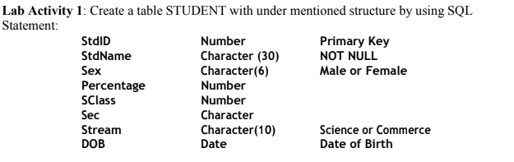

**Answer:**

**Table creation :**

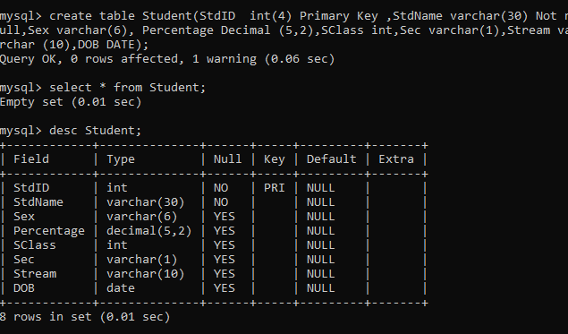

**Insertion of data:**

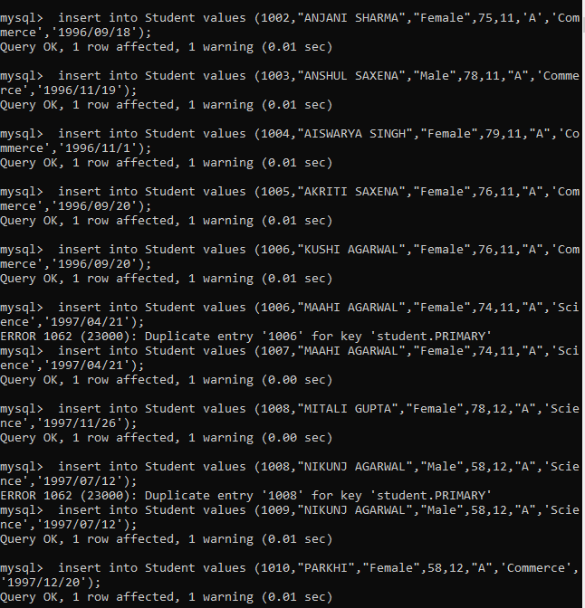

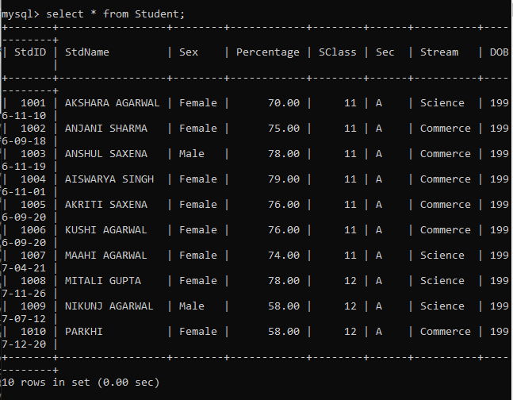

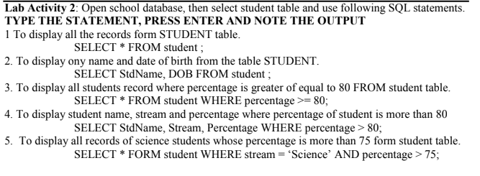

Answer:

1 To display all the records form STUDENT table.

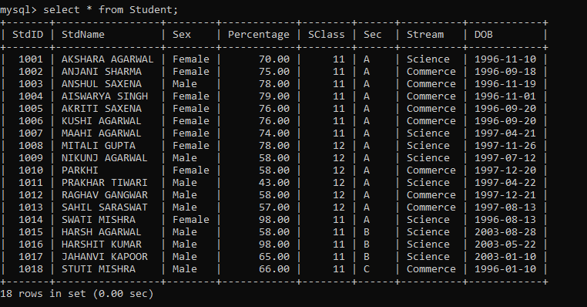

2. To display ony name and date of birth from the table STUDENT.

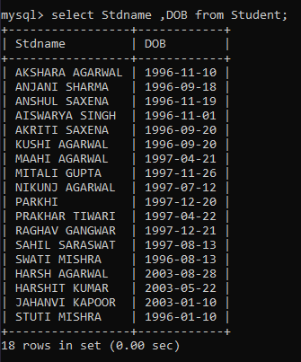

3. To display all students record where percentage is greater of equal to 80 FROM student table.

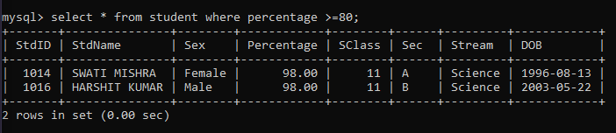

4. To display student name, stream and percentage where percentage of student is more than 80

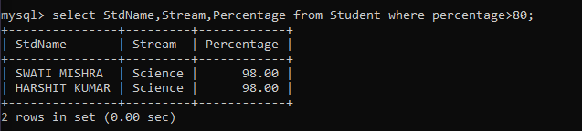

5. To display all records of science students whose percentage is more than 75 form student table.

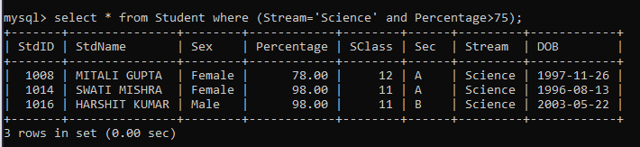



1. To display the STUDENT table structure.

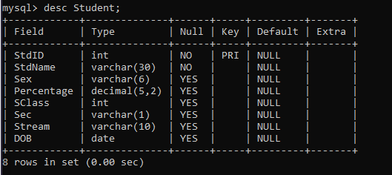

2. To add a column (FIELD)in the STUDENT table,for example TeacherID as VARCHAR(20);

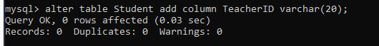

3. Type the statement

DESC Student;

Press enter key, now note the difference in table structure.

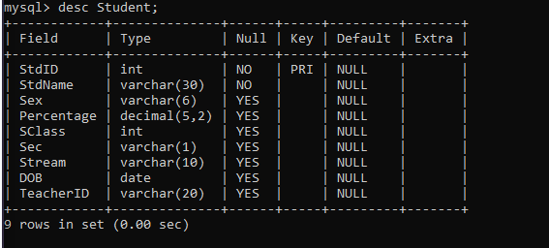

4. Type the statement and press enter key, note the new field that you have added as TeacherID

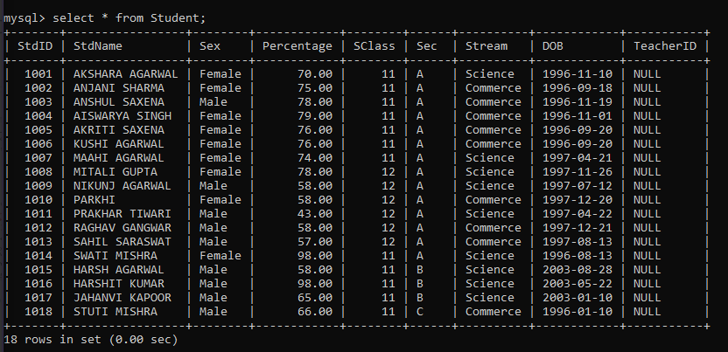

5. To modify the TeacherID data type form character to integer.

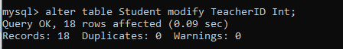

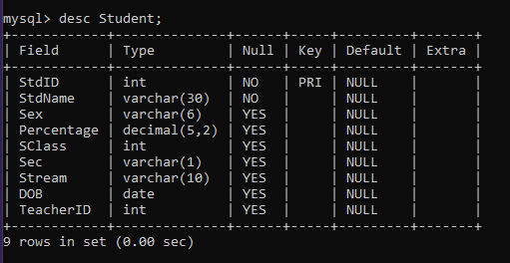

**Lab Activity 4**

1. To Drop (Delete) a field from a table. For e.g you want to delete TeacherID field.

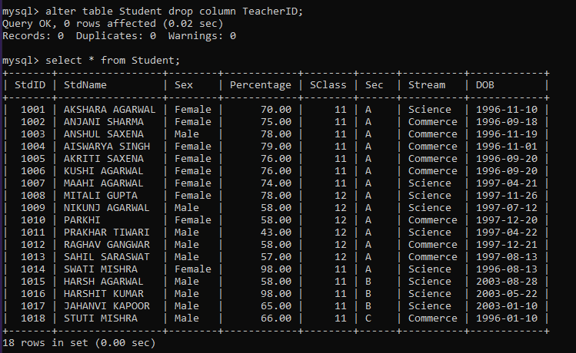

2. To subtract 5 from all students' percentage and display name and percentage.

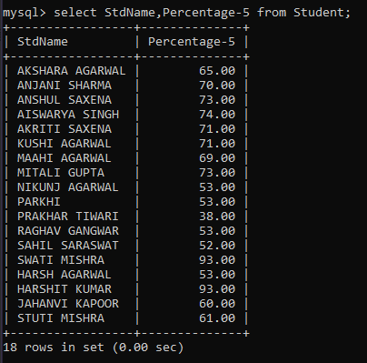

3. Using column alias for example we want to display StdName as Student Name and DOB as Date of Birth

then the statement will be.

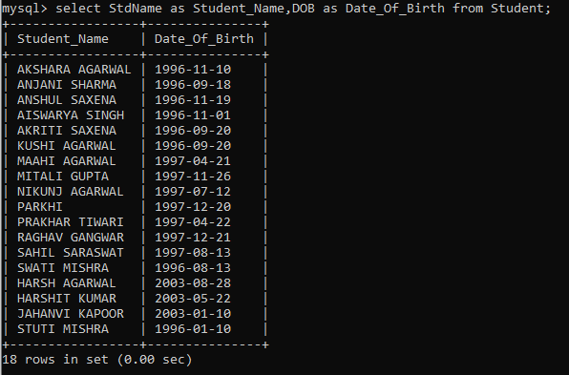

4. Display the name of all students whose stream is not Science.

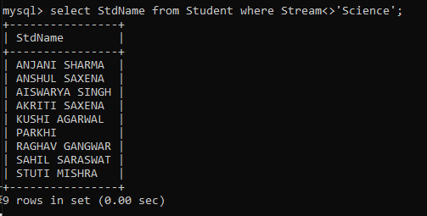

5. Display all name and percentage where percentage is between 60 and 80

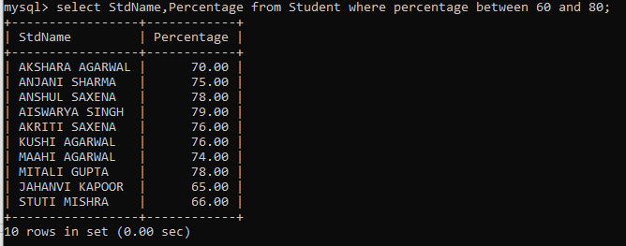

Lab Activity 5:

1. To change a student name from SWATI MISHRA to SWATI VERMA whose StdID is 1014 and also change percentage 86.

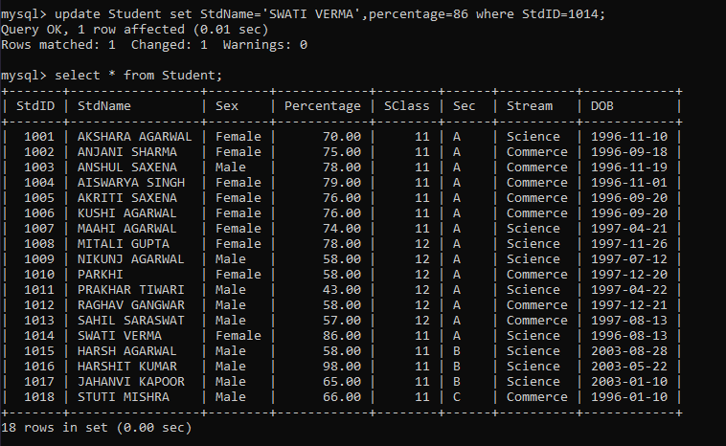

2. To delete the records form student table where StdId is 1016.

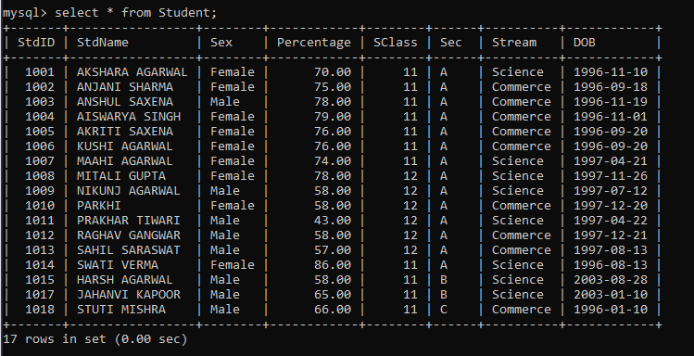

3. Type the following SQL statement and note the output.

SELECT * FROM Student WHERE StdName LIKE 'G_' ;



SELECT * FROM Student WHERE StdName='G';



SELECT * FROM Student WHERE StdName LIKE 'G%' ;



SELECT * WHERE Student WHERE StdName='%G%' ;



4. Display all the streams in student table.

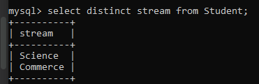



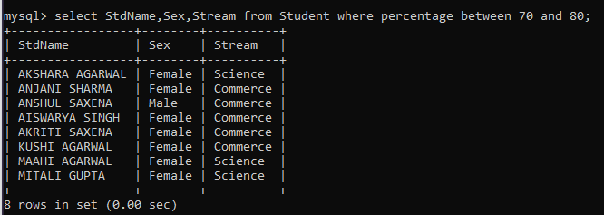

**Do yourself:**

Create a Table Empl to store employee details as shown below and write statements

for following queries based on the table.

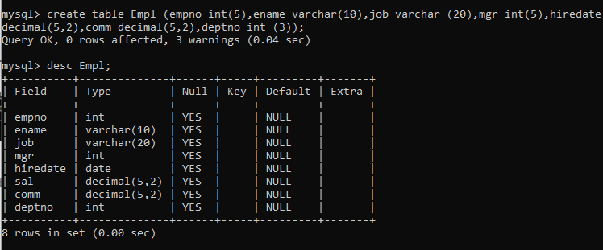



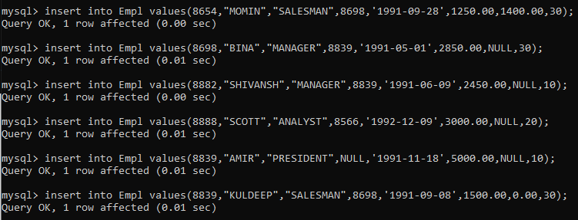

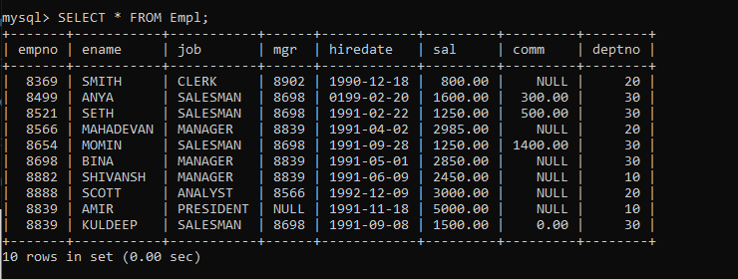

a. Write a query to display EName and Sal of employees whose salary are greater than

or equal to 2200?

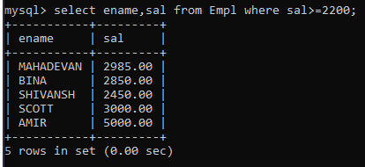

b. Write a query to display details of employs who are not getting commission?

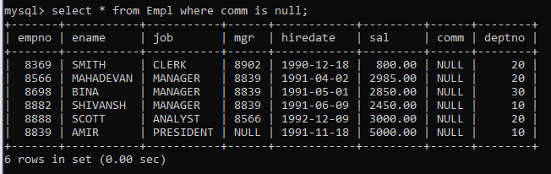

c. Write a query to display employee name and salary of those employees who don’t have

their salary in range of 2500 to 4000?

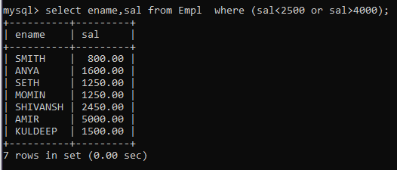

d. Write a query to display the name, job title and salary of employees who don’t have manager?

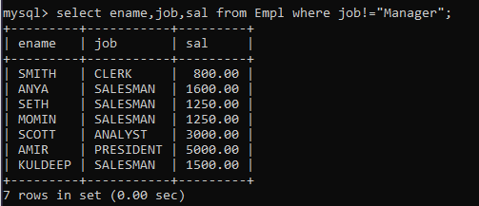

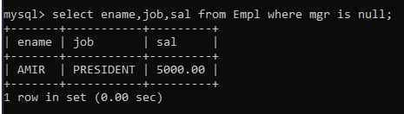

e. Write a query to display the name of employee whose name contains “A” as third alphabet?

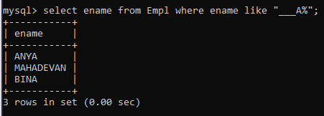

f. Write a query to display the name of employee whose name contains “T” as last alphabet?

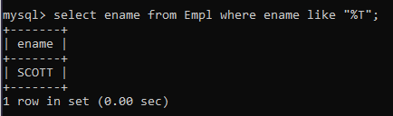

g. Write a query to display the name of employee whose name contains ”M” as First and

“L” as third alphabet?

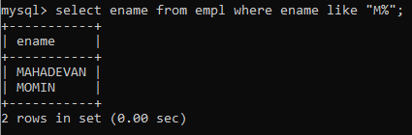

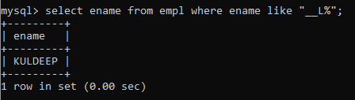

h. Write a query to display details of employs with the text “Not given”, if commission is null?

